**Main Tab**

*Lines 1-2*

PImage class used to store a .png image which is saved in the data directory of my processing sketch. Int bgX = 0; in line 2 of the main tab sets the x-position at point 0 of the x-axis (left side of the screen). 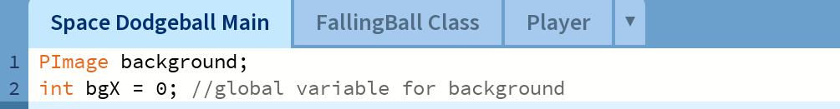

*Lines 4-8*

Setup function runs once, initialises things within the program. Here it sets the screen size for the game which is 600x600 pixels, it also loads the image file and assigns it to the background variable, resizes the image to fit the game screen size and calls the “playerdet” class from the player tab of the program. 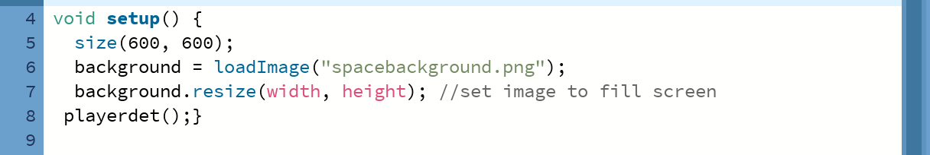

Lines 10-18

Draw function runs nonstop and oversees updating of each frame. Line 11 checks to see if the game is paused, in the context of this game, happens when a collision is detected, if not, it continues to run. Image background draws background at two positions to create scrolling effect. Line 16-17 resets background position when first image has moved off. 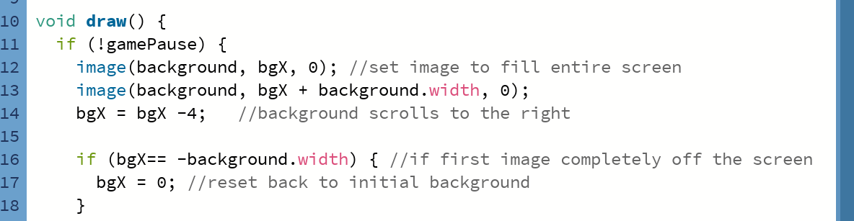

Lines 20-29

21-29 is a for loop that goes through the list of balls in the array list from first to last, updating each one. 23 calls the update method to move balls down screen. 24 draws the balls. 27 checks if player and ball has collided, if true game will pause. 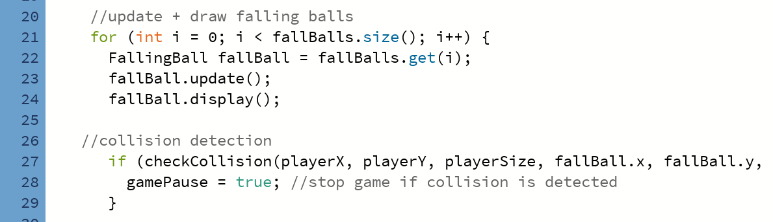

Lines 31-37

Line 31 removes any balls that fall past the screen. 35 adds new balls to list every 6 frames (1 second). 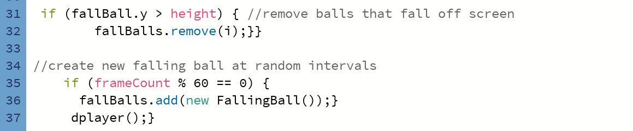

Lines 39-43

Include what will show on the screen when collision occurs. “Game over!” in red text at centre of screen.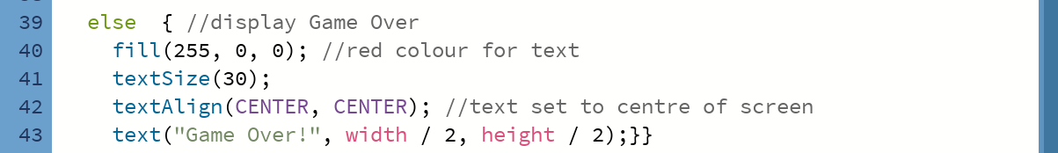

Line 45

Controls if game should stop or not after collision.

Lines 48-50

Checks if player collided with falling ball, calculates dist() between them, if player size is bigger than space between them, collision happens. 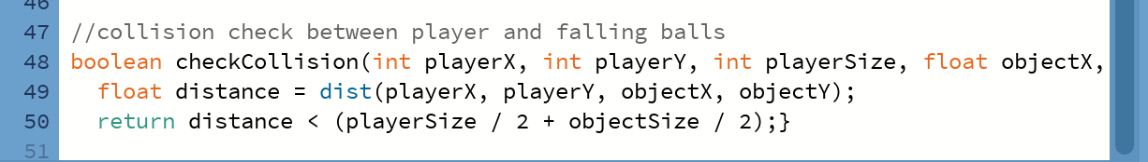

**FallingBallClass Tab**

*Line 1*

This line contains an Array list which functions to store the game’s objects, in this case its the falling balls, which will fall from the top of the screen and interact with the player (collide). 

Lines 3-10

Sets balls’ class, x position to a random value and Y to 0 so they start from top of screen. Size is anything between 35-50px. Speed is random at 5-10px. 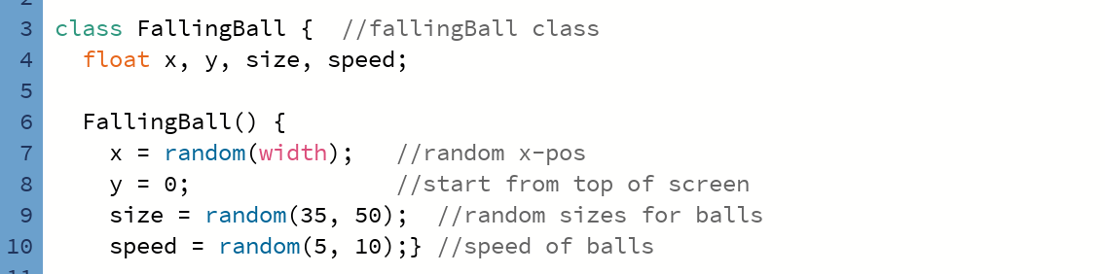

Lines 12-13

Moves balls down screen by its speed value. 

Lines 15-17

Draws ball on screen as orange circles with its coordinates. 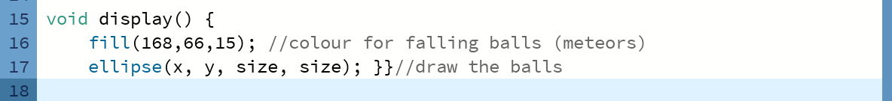

**Player Tab**

*Lines 1-3*

This section of my code determines where the player appears on the X and Y axis, which positions will be initialised later in the program. Player Size is set to 40, this line determines how large the player will be displayed on the screen.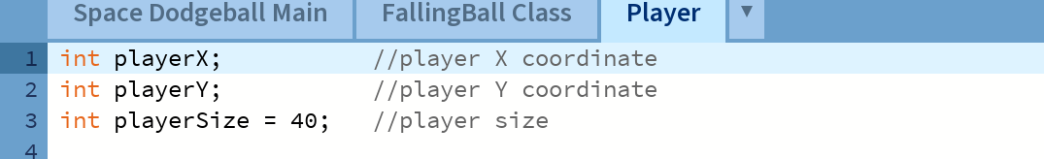

*Line 5-8*

The “playerdet” class contains the player’s width, height and location on the screen. X axis sets the player to centre of screen, but Y axis moves the player down a little. 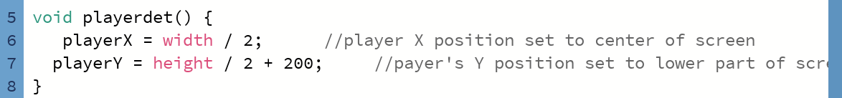

*Lines 9-13*

Player is coloured green 40px at current position. 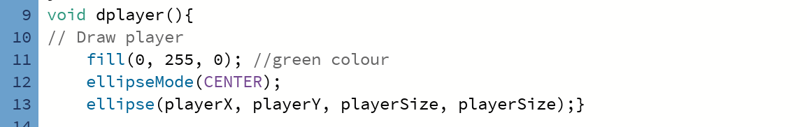

*Lines 15-20*

If left key pressed, player moves to the right “playerX +=20;” and vice versa.